10.2.4 Render - Blender Render Engine - World
Introduction 1
World 3
Lamp options 3
Sky & Atmosphere 4
Shadow 4
World Background 4
Description 5
Options 5
Textures 6
Mist 7
Description 7
Option 7
Transparency 8
Examples 8

Introduction

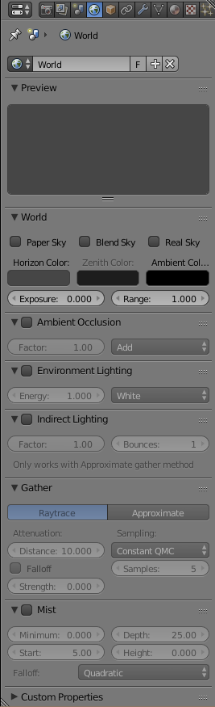
World Panel
Bforartists provides a number of very interesting settings to complete your renderings by adding a nice background, and some interesting ‘depth’ effects. These are accessible via the World context. By default a very plain uniform world is present. You can edit it or add a new World.
You have:
Background
The color and texture of the world background, with special settings for mapping coordinates.
Mist
Add a mist to your scene to enhance the feeling of depth.
While these world settings offers a simple way of adding effects to a scene, compositing nodes are often preferred, though more complex to master, for the additional control and options they offer. For example, filtering the Z value (distance from camera) or normals (direction of surfaces) through compositing nodes can further increase the depth and spacial clarity of a scene.
Note
Some of the settings under the World panel in Bforartists affect lighting so you find them under the Lighting chapter (see Ambient Light, Exposure and Ambient Occlusion). When using a Sun Lamp options for Sky & Atmosphere are available in the Lamp menu.

World

A Sun lamp provides light of constant intensity emitted in a single direction. A Sun lamp can be very handy for a uniform clear daylight open-space illumination. In the 3D view, the Sun light is represented by an encircled black dot with rays emitting from it, plus a dashed line indicating the direction of the light.
This direction can be changed by rotating the Sun lamp, like any other object, but because the light is emitted in a constant direction, the location of a Sun lamp does not affect the rendered result (unless you use the “sky & atmosphere” option).
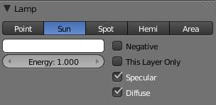
Sun lamp panel

Lamp options
Energy and Color
These settings are common to most types of lamps, and are described in Light Properties.
Negative, This Layer Only, Specular, and Diffuse
These settings control what the lamp affects, as described in What Light Affects.
The Sun lamp has no light falloff settings: it always uses a constant attenuation (i.e. no attenuation!).

Sky & Atmosphere
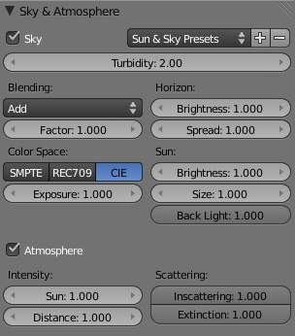
Sky & Atmosphere panel
Various settings for the appearance of the sun in the sky, and the atmosphere through which it shines, are available. For details, see Sky and Atmosphere.

Shadow
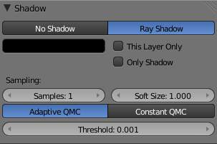
Shadow panel
The Sun light source can only cast ray-traced shadows. It shares with other lamp types the same common shadowing options, described in Shadows Properties.
The ray-traced shadows settings of this lamp are shared with other lamps, and are described in Raytraced Properties.

World Background

Description
The world buttons let you set up the shading of your scene in general. It can provide ambient color, and special effects such as mist, but a very common use of a World is to shade a background color.
Note
Background Image in Render
To use an image as your render background, see BackBuf images specified in the Output Panel

Note
Background Image in 3D
To use an image as a background image in your 3D view, for example as a reference when doing a model, see using a Background Image

Options
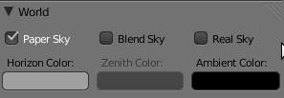
World panel
Horizon Color
The RGB color at the horizon
Zenith Color
The RGB color at the zenith (overhead)
How these colors are interpreted depends on which kind of Sky is chosen.
None Enabled
If none of these three buttons is checked, your background will just be plain flat color (using the horizon one).
Paper Sky
If this option is added, the gradient keeps its characteristics, but it is clipped in the image (it stays on a horizontal plane (parallel to x-y plane): what ever the angle of the camera may be, the horizon is always at the middle of the image).
Blend Sky
The background color is blended from horizon to zenith. If only this button is pressed, the gradient runs from the bottom to the top of the rendered image regardless of the camera orientation.
Real Sky
If this option is added, the gradient produced has two transitions, from nadir (same color as zenith) to horizon to zenith; the blending is also dependent on the camera orientation, which makes it more realistic. The horizon color is exactly at the horizon (on the x-y plane), and the zenith color is used for points vertically above and below the camera.

Textures
Instead of a color, or blend of two colors, Bforartists can use an 2D image which it maps to a very large Box or sphere which encompasses the entire scene, or which it maps to a virtual space around the scene.
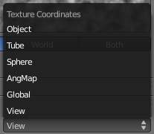
Texture Coordinates pop-up menu
The World textures are accessible in the texture menu (just select World first, then Texture. They are used much like the Materials textures, except for a couple of differences. The textures can be mapped according to:
View
The default orientation, aligned with the co-ordinates of the final render
Global
Uses global coordinates
AngMap
Used to wrap a standard hemisphere angular map around the scene in a dome. This can be used for image based lighting with Ambient Occlusion set to sky color. You’ll generally need a high dynamic range image (HDRI) angular map. (It will look like a weird spherical image).
Sphere
Sphere mapping, similar to that of materials
Tube
Wrap the rectangular texture around in a cylinder, similar to that of materials
Object
Position the texture relative to a specified object’s local texture space
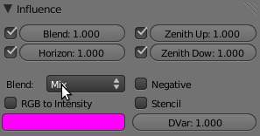
Texture Influence panel
The texture affects color only, but in four different ways:
Blend
Makes the Horizon color appear where the texture is non-zero
Horizon
Affect the color of the horizon
Zenith Up
Affect the zenith color overhead
Zenith Down
Affect the zenith color underneath
If you are disappointed that your camera appears to carry the texture with it rather than rotate through the texture, you should check the Real Sky checkbox in the World tab of the Properties view.

Mist

Description
Mist can greatly enhance the illusion of depth in your rendering. To create mist, Bforartists makes objects farther away more transparent (decreasing their Alpha value) so that they mix more of the background color with the object color. With Mist enabled, the further the object is away from the camera the less it’s alpha value will be.

Option
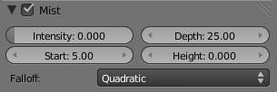
Mist panel
Mist check box
Toggles mist on and off
Minimum
An overall minimum intensity, or strength, of the mist.
Start
The distance from the camera at which the mist starts to fade in
Depth
The distance from Start of the mist, that it fades in over. Objects further from the camera than Start+Depth are completely hidden by the mist.
Height
Makes the mist intensity decrease with height, for a more realistic effect. If greater than 0, it sets, in Bforartists units, an interval around z=0 in which the mist goes from maximum intensity (below) to zero (above).
Falloff
The decay rate of the mist (Quadratic / Linear / Inverse Quadratic). These settings control the rate of change of the mist’s strength further and further into the distance.
Note
Mist distances
To visualize the mist distances in the 3D View, select your camera, go to the camera menu, and enable Show Mist.
The camera will show mist limits as a line projecting from the camera starting from Start and of distance Depth.
To get a better view to evaluate the Mist visualization, Shift-Numpad1 with the camera selected (Numpad5 to toggle perspective view on and off). This will place the 3D view right over the camera looking down.

Transparency
Because Mist works by adjusting transparency, this can sometimes cause objects to be partially transparent when they shouldn’t be. One workaround is to set the Mist settings as desired, but turn Mist off. The Mist data is still available for compositing even though it is off. Use Do Composite and the Node Editor to feed the Mist pass to an AlphaOver to blend the background color (or a render layer with just the sky) with the rendered image. This produces the mist effect but since Mist is off the object transparency (or lack of) is preserved.

Examples
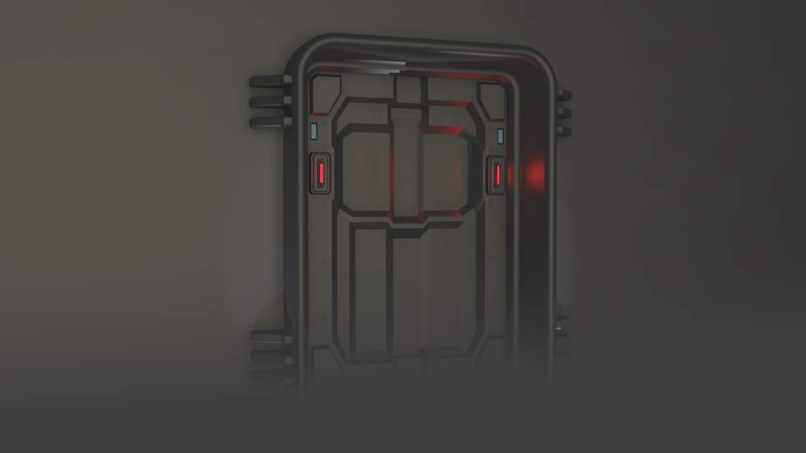
Mist example
In this example the Mist Height options has been limited to create smoke covering the floor.
This simple scene was inspired by Stefan Morell’s Arc Sci-Fi Corridor.

